Exercise-01
Logger.java
public class Logger {
// Step 1: Create only one object
private static Logger instance;
// Step 2: Private constructor
private Logger() {
System.out.println("Logger Instance Created");
}
// Step 3: Public method to access the single object
public static Logger getInstance() {
if (instance == null) {
instance = new Logger();
}
return instance;
}
// Step 4: Logging method
public void log(String message) {
System.out.println("Log: " + message);
}
}
TestLogger.java
public class TestLogger {
public static void main(String[] args) {
Logger logger1 = Logger.getInstance();
logger1.log("Application Started");
Logger logger2 = Logger.getInstance();
logger2.log("User Logged In");
if (logger1 == logger2) {
System.out.println("Both logger1 and logger2 are the same instance.");
} else {
System.out.println("Different instances.");
}
}
}

Outputs:
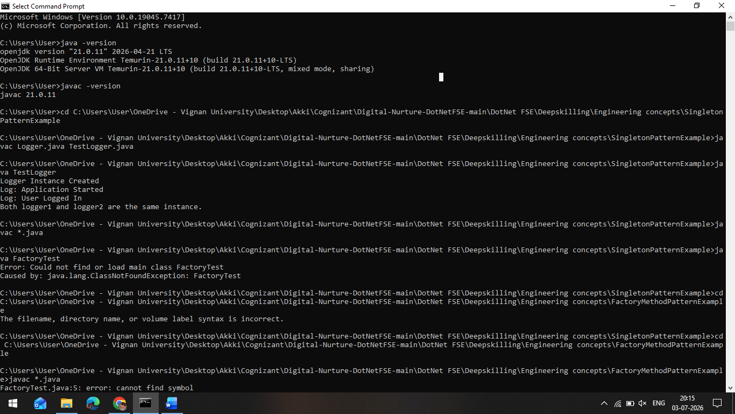

Exercise-02:
Document.java
public interface Document {
void open();
}
WordDocument.java
public class WordDocument implements Document {
@Override
public void open() {
System.out.println("Word Document Opened");
}
}
PdfDocument.java
public class PdfDocument implements Document {
@Override
public void open() {
System.out.println("PDF Document Opened");
}
}
ExcelDocument.java
public class ExcelDocument implements Document {
@Override
public void open() {
System.out.println("Excel Document Opened");
}
}
DocumentFactory.java
public abstract class DocumentFactory {
public abstract Document createDocument();
}
WordFactory.java
public class WordFactory extends DocumentFactory {
@Override
public Document createDocument() {
return new WordDocument();
}
}
PdfFactory.java
public class PdfFactory extends DocumentFactory {
@Override
public Document createDocument() {
return new PdfDocument();
}
}
ExcelFactory.java
public class ExcelFactory extends DocumentFactory {
@Override
public Document createDocument() {
return new ExcelDocument();
}
}

FactoryTest.java
public class FactoryTest {
public static void main(String[] args) {
DocumentFactory wordFactory = new WordFactory();
Document word = wordFactory.createDocument();
word.open();
DocumentFactory pdfFactory = new PdfFactory();
Document pdf = pdfFactory.createDocument();
pdf.open();
DocumentFactory excelFactory = new ExcelFactory();
Document excel = excelFactory.createDocument();
excel.open();
}
}

Outputs:
